- Resolve Merge Conflicts
First we need to create file in one branch and add and commit, then we need to switch to another branch with same file name and we need to do merge conflict
Here we can see two identical files with same content
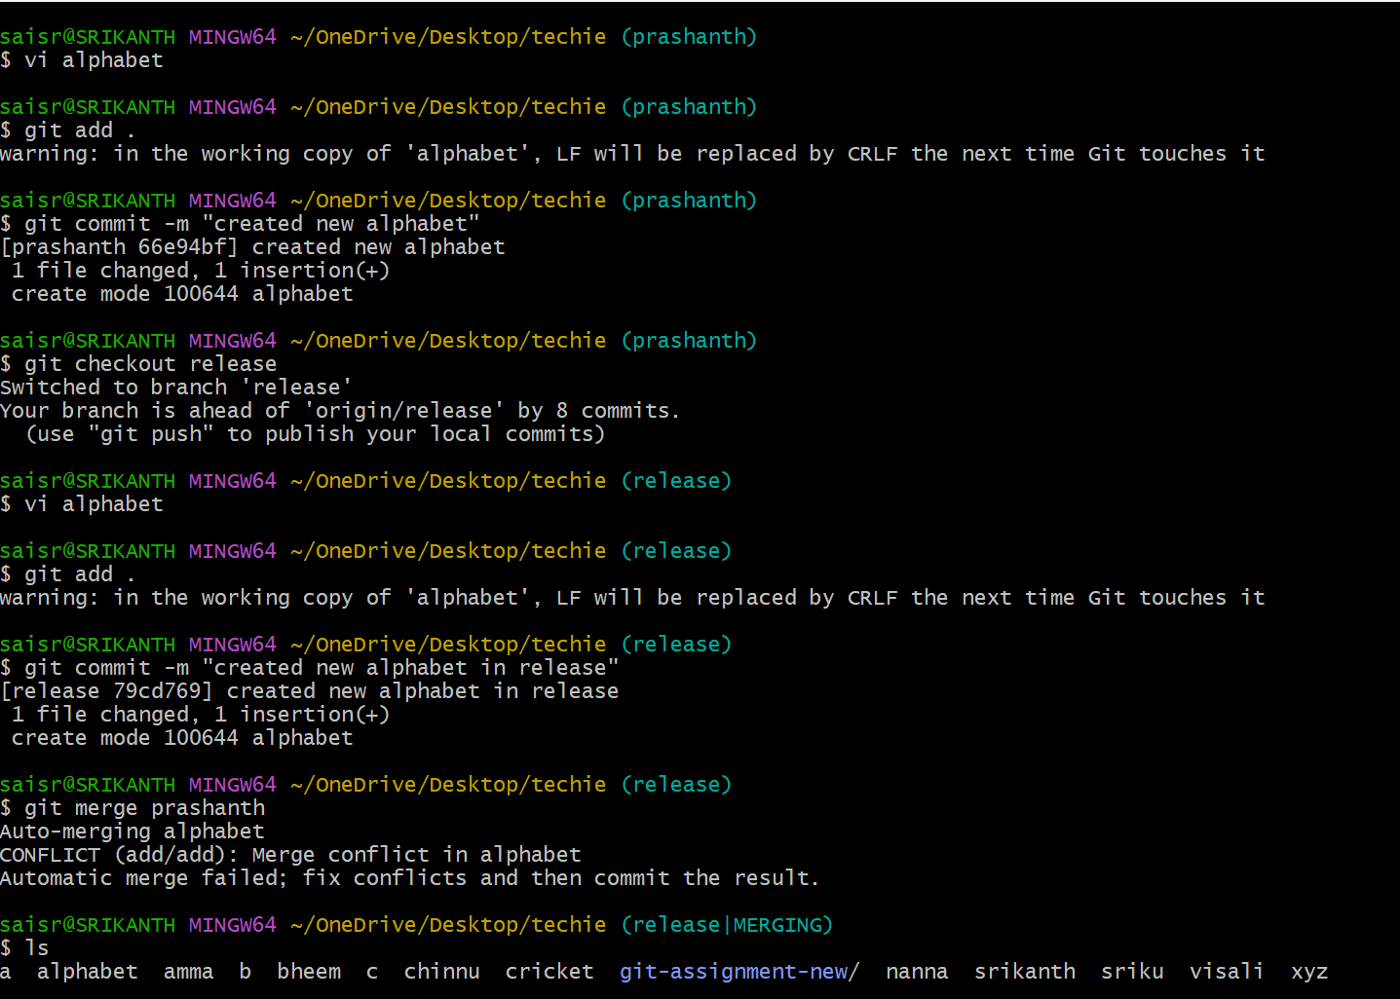
- Recover Deleted Branch
First create branch and see in branch list
Then delete the branch by using git branch -D branchname
To recover the deleted branch we need to use git git branch branchname commit id
In the place of branch name u need to deleted branchname
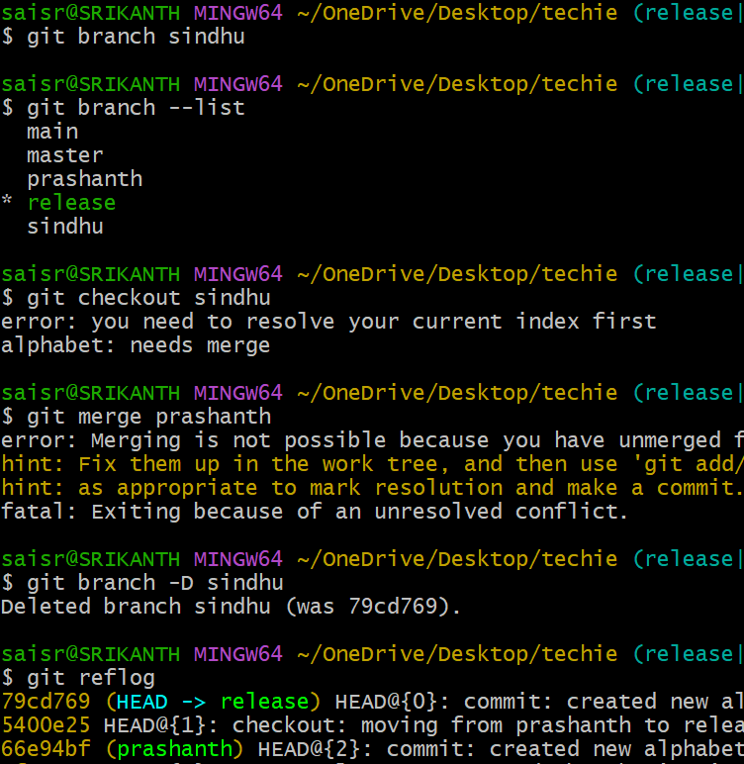
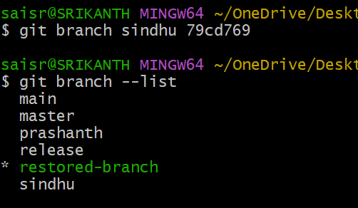
    - Undo Wrong Push
Created a file and added and committed and pushed to the repository
I reverted the changes using commit id
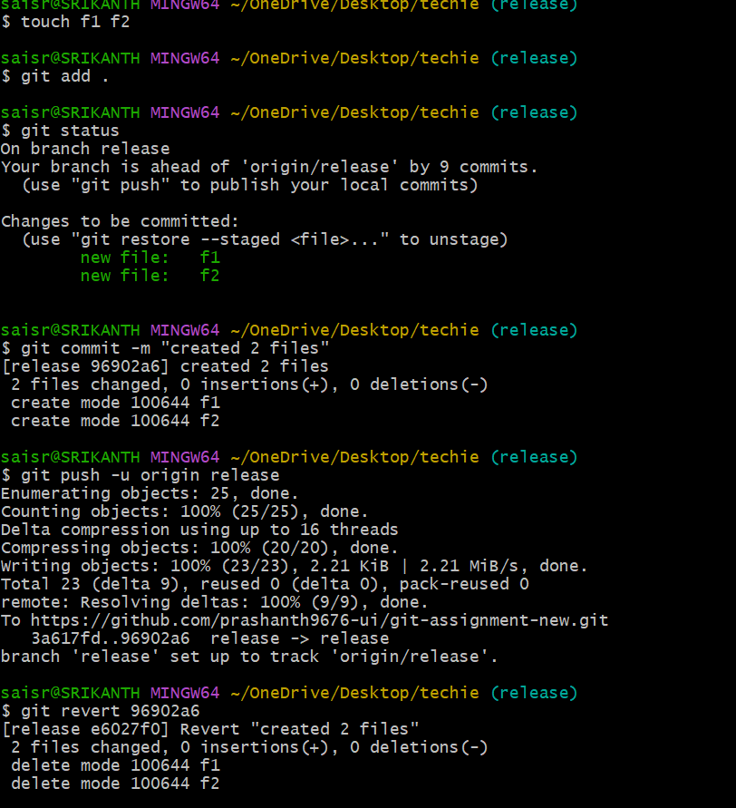
.
    - Amend a Commit
By using the git commit –amend we can make changes in the commit
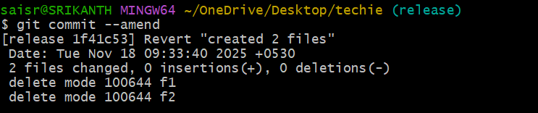
    - Cherry-pick a Commit
First used git log in release branch
Displayed the commit files
Got switched to another branch Sindhu
Now I used git cherry-pick commit id to apply particular commit to new branch
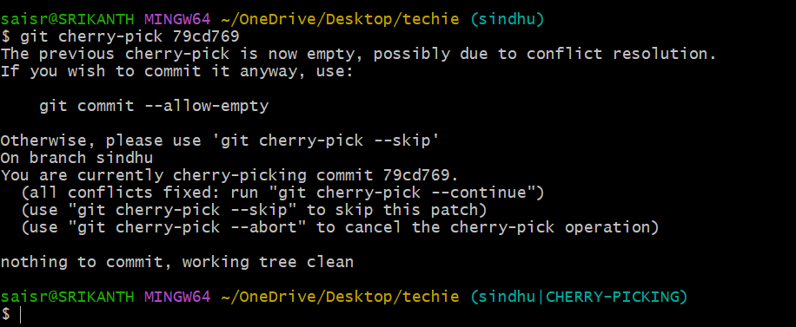

.
    - Interactive Rebase
First I used git log-4
I have seen four committed files
git rebase -I HEAD~1 is the command used to merge 4 commits into single commit
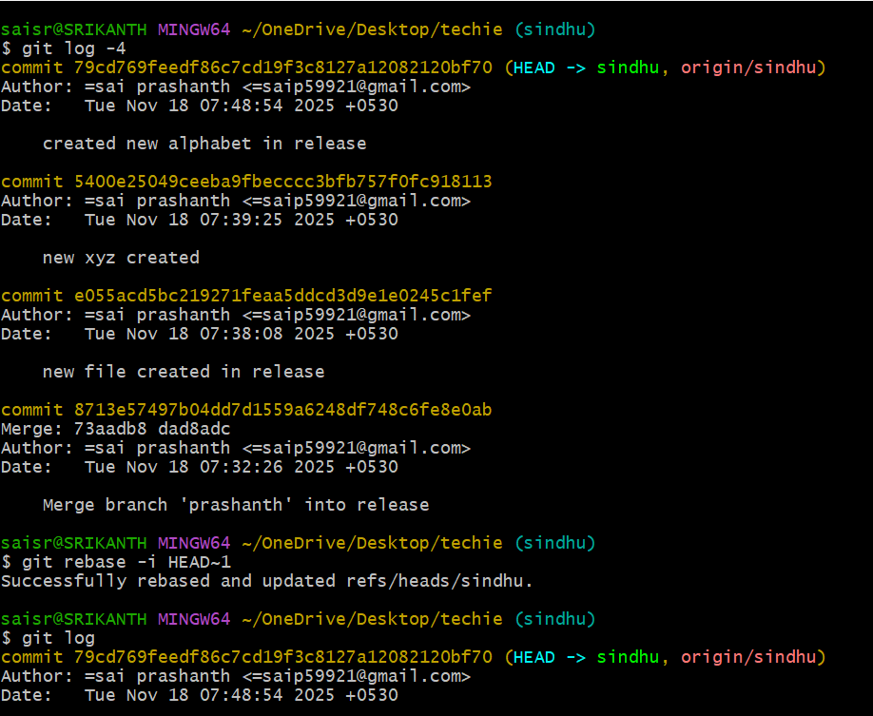

    - Tagging & Release
First created a tag git tag v1.0.0 and pushed into central repository and deleted it by using git tag -d v1.0.0
Then restored the tag by using commit id git tag v1.0.0 commit id
By running it by using git tag
We can see v1.0.0
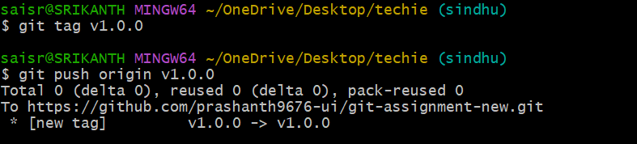
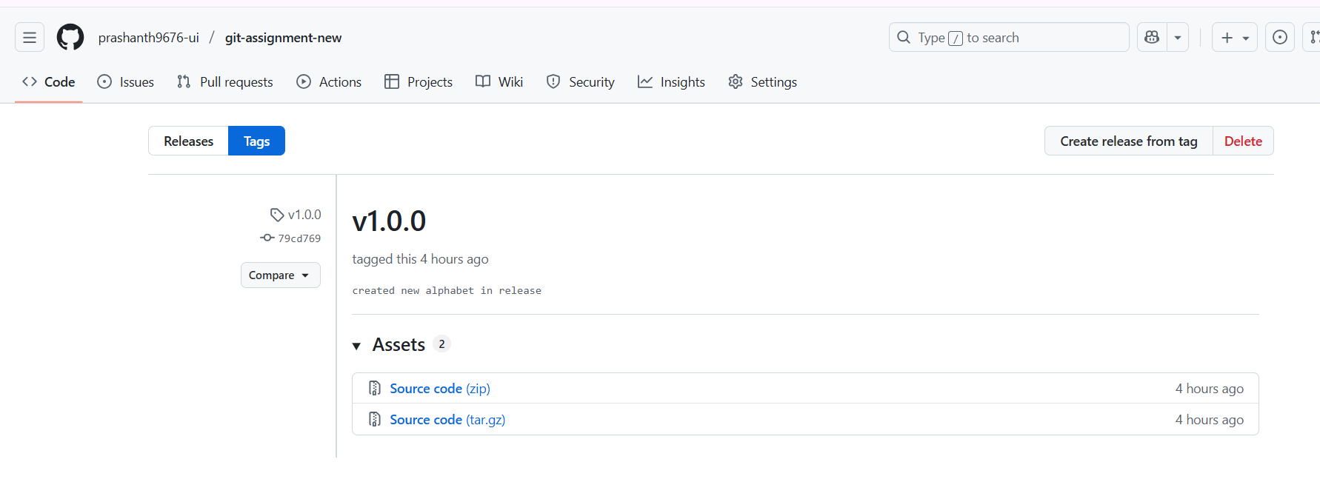
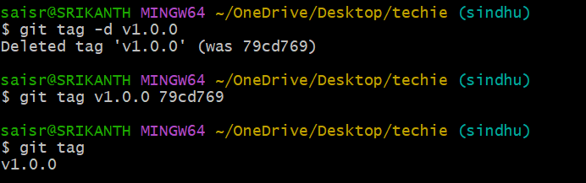
    - Clone with Sparse Checkout
It allows you tom clone the entire history and metadata of a repository, but only checkout particular files or subdirectories into your local machine
It is used to work efficiently by avoiding the downloading of unnecessary data, saving space and time
First, we need to close the repository and we need to initiate sparse-checkout
Next to see the only a particular file not whole repository we need to use git sparse-checkout (subdirectory)
To check list use git sparse-checkout list
U can see the filename
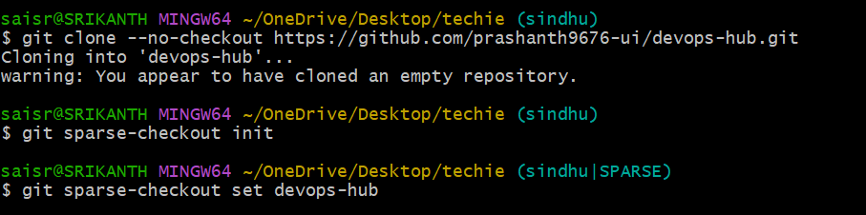
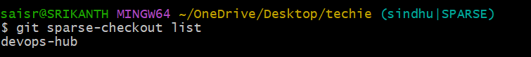

      - Reset vs Revert Challenge
git reset --hard
It resets your branch to a specific commit and deleted all your local changes.
It doesn’t ask for editing and commit the message
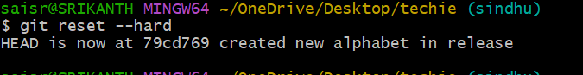
Git revert- it is used to undo a commit by creating new commit
First, we need to use git log
Now we need to select whoch commit file you need to revert
Use git revert commitid
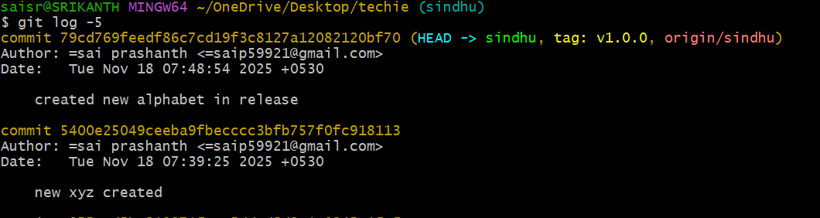
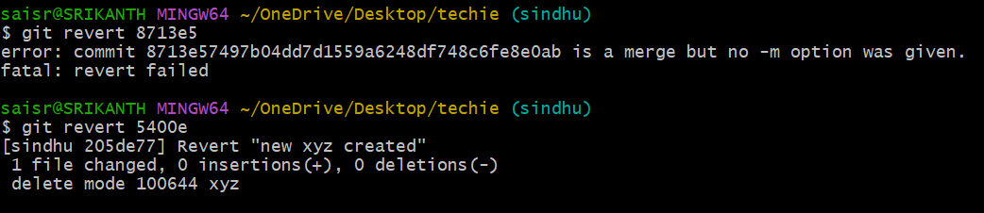

      - Detached HEAD Challenge
First you need to use git log command to list the commits
Next you need to use git log –online command to see detached head pointer directly to the commit
Switching to the branch using commit id
By using the git branch –list you can see the branches list along with new branch created
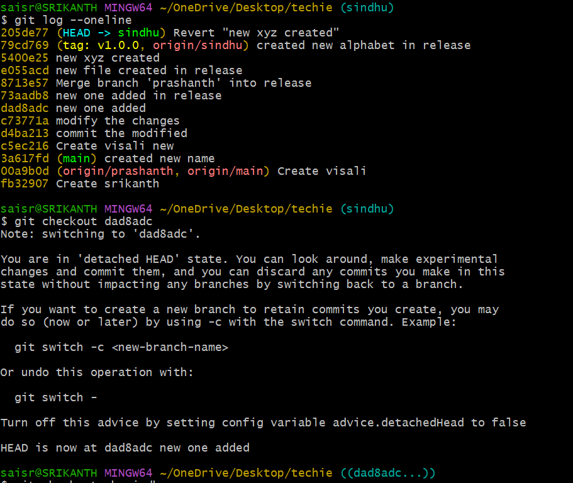
      - Squash Merge vs Rebase Merge
Squash merge
It combines all the commits from a feature branch into single commit and then merges it into the neww branch.
using command git merge branch –squash to merge to release branch

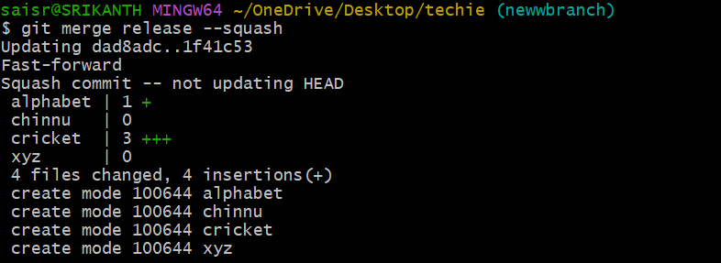
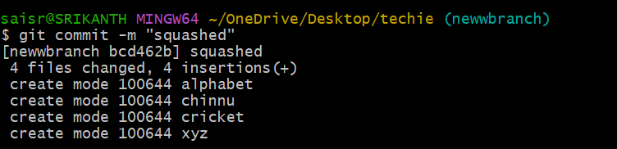
12 Fork & Pull Request Workflow

it is a repository under your own account
Fork a repo, make a change, and submit a pull request to the original repo
You copy someone else’s repo into your github account
Create a pull request requesting the original repo owner to merge your
changes

first need to do git clone and add the url
make the git add . and git commit and git push
once if you refresh your history u can see the file and added any in that

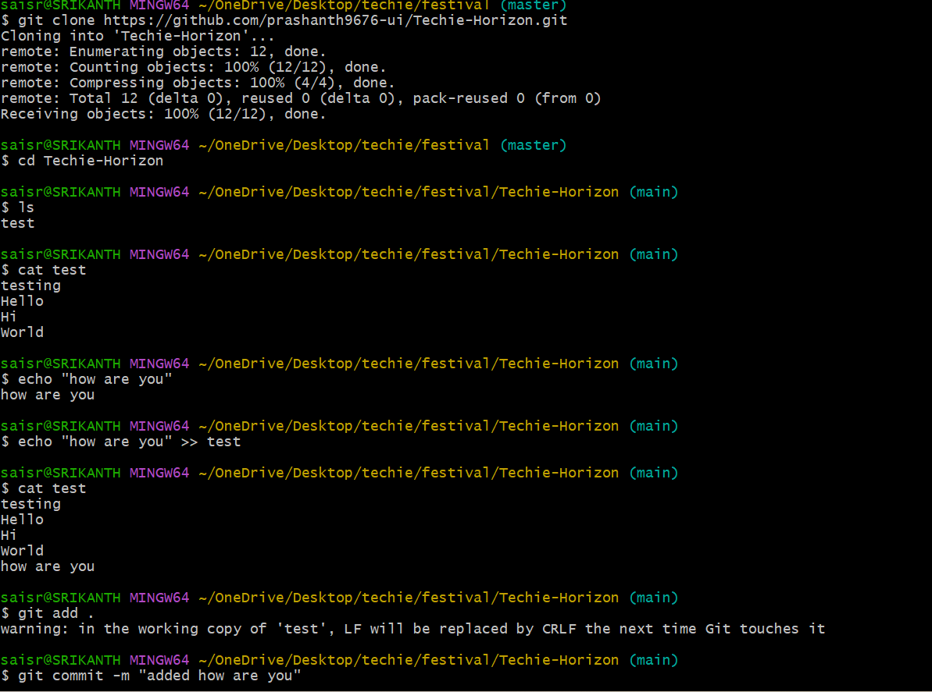
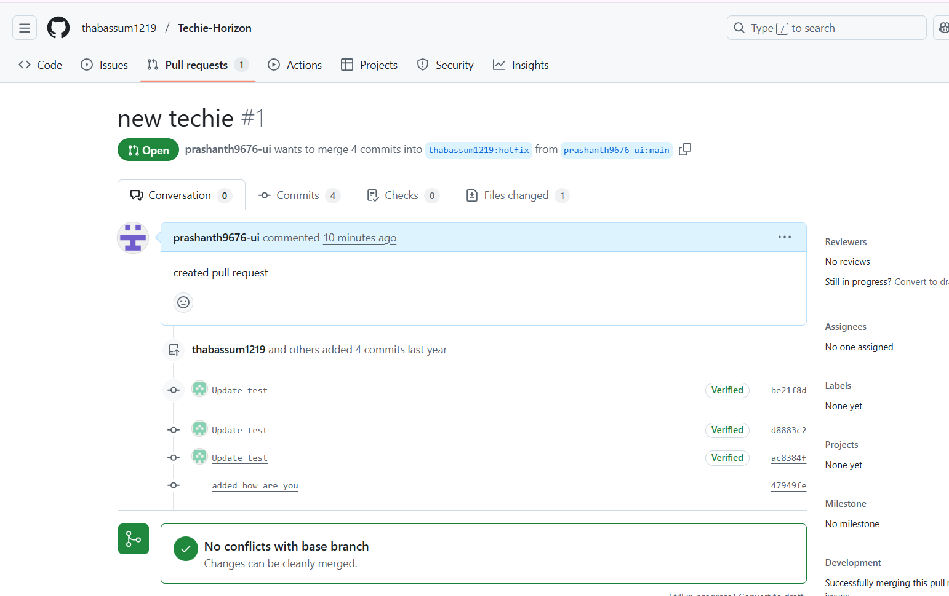

- Recover Lost Commit

Commit something, reset hard, and then recover it using git reflog.
Just added few lines for n existing file and git add,git commit -m commands
are used. By using git log –online -1.
To restore the lost commit use git reset –hard commit id
By using git log –oneline we can confirm recovery.

